To start:

Python start.py config.ini

Go to <url:23456>

Click on enroll face

Then click on recognize face

Screenshot:

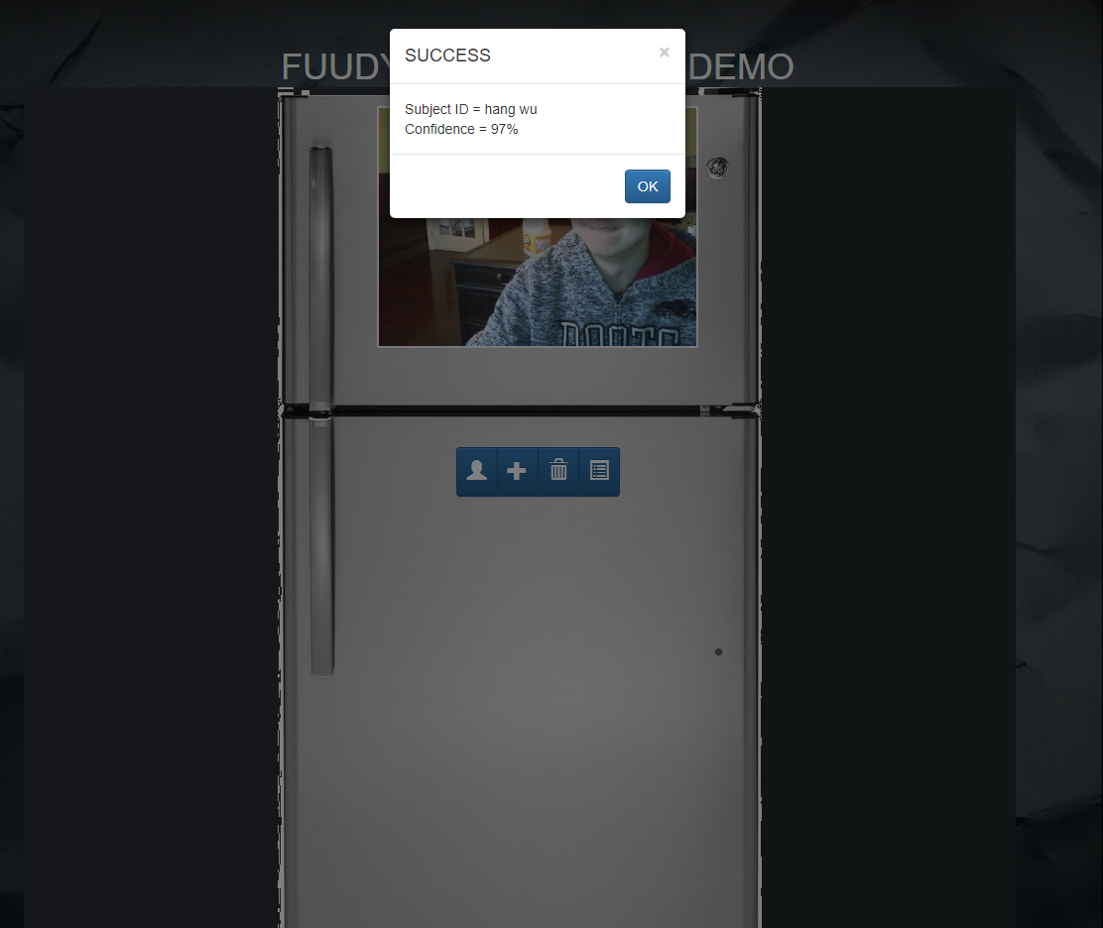

Reference:

https://github.com/GetFuudyorg/Online-Demo code也在上面

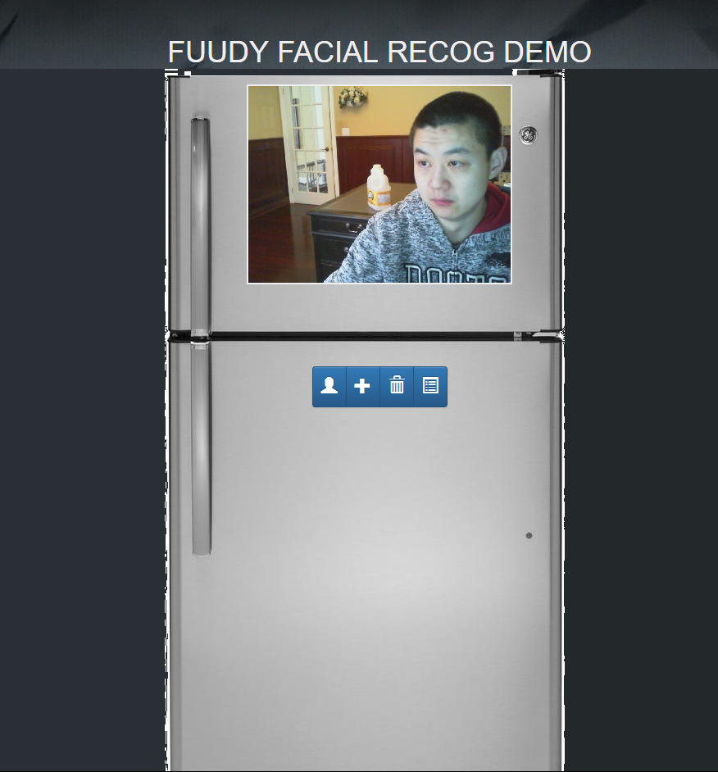

Next step: automatically recognize face and store images, then issue the open door animation.